16.03.2020r. – poniedziałek

Zadanie 1. Places in Town –słownictwo – część 2:

- Police station (pelis stejszyn) – posterunek policji
- Post office (połst ofis) – poczta
- Shopping Centre (szopin senter) – centrum handlowe
- Sports centre (sports senter) – ośrodek sportowy
- Swimming pool (słimin pul) – basen
- Train station (trejn stejszyn) – dworzec kolejowy

Wymowa:
- Police station : https://dictionary.cambridge.org/dictionary/english/police-station
- Post office : https://dictionary.cambridge.org/dictionary/english/post-office
- Shopping centre : https://dictionary.cambridge.org/dictionary/english/shopping-centre
- Sports centre : https://dictionary.cambridge.org/dictionary/english/sports-centre
- Swimming pool : https://dictionary.cambridge.org/dictionary/english/swimming-pool
- Train station : https://dictionary.cambridge.org/dictionary/english/train-station

Zadanie 2. Przeczytaj tekst. Następnie odpowiedz na pytania poniżej.
Dear Nicky,
How are you? I am in Madrid now and I am writing to tell you about my new flat. It’s a beautiful city and I think that you must visit me soon.
I live in a block of flats in the centre of Madrid. I share the flat with other students from university. It’s cosy and spacious. When you go in, there is a long hall. On the left, there is a kitchen and a bathroom. We have a nice living room where we spend a lot of time watching TV and talking about parties. Next to the living room, there is my room.
It’s my favourite place. It’s small, but in very good condition. I have a grey sofa, two armchairs and a round coffee table. In my room, there aren’t many paintings on the walls. There is a white carpet on the floor and there are green curtains on the windows. There are three flowerpots on the window sill. There is a wooden desk and a chair in front of the window. I keep a computer and books on it. There is a comfortable bed next to the desk. I love the wardrobe which is in the corner of the room. I have a lot of clothes there. I’m sending a few pictures so that you can see if my room looks nice.
This is all for now. I want a letter from you, too.
Bye,
Olivia
Słowniczek:
- block of flats – blok mieszkalny
- in the centre of (the city) – w centrum miasta
- share – dzielić (np. mieszkanie)
- cosy and spacious – przytulny i przestronny
- in good condition – w dobrym stanie
- flowerpot – doniczka
- window sill – parapet

Pytania do tekstu:

- Where does Olivia live (city)?
- Does she live alone or with other people?
- What is Olivia’s favourite place?
- What kind of furniture does Olivia have?
- Does Olivia like her new place?

Twoje odpowiedzi:

- …………………………………………………………………………………………………………………………………………….
- …………………………………………………………………………………………………………………………………………….
- …………………………………………………………………………………………………………………………………………….
- …………………………………………………………………………………………………………………………………………….
- …………………………………………………………………………………………………………………………………………….

17.03.2020r. – wtorek

Zadanie 1. Daty w języku angielskim

Tutaj trzeba jednak zapamiętać, że Anglicy znacznie ułatwili sobie sprawę i cyferki w roku czytają trochę inaczej. Dzielą go mianowicie na pół: 1856 po angielsku to nie tysiąc osiemset pięćdziesiąty szósty, lecz osiemnaście pięćdziesiąt sześć.
Kilka przykładów:
1789 | seventeen eighty-nine
1975 | nineteen seventy-five
1466 | fourteen sixty-six

Natomiast wszystkie lata rozpoczynające nowe stulecie czyli 1700, 1500, 1900 czytają jako...
1700 | seventeen hundred
1500 | fifteen hundred
1900 | nineteen hundred

Lata 1000 i 2000 przeczytamy jako:
1000 | one thousand
2000 | two thousand
1001 | one thousand (and) one

Zadanie 2. Wpisz słownie daty:

- In …………………………………………………. 2015 I will be thirty-five.
- The battle of Grunwald was fought in …………………………………………………….. 1410.
- Did anything important happen in …………………………………………………………. 1800?
- My grandfather was born in Warsaw in …………………………………………………… 1921.
- I went to Germany in ………………………………………………………………. 1976 and stayed there for ten years.
- It’s …………………………………………………………………….. 2020 now.

Zadanie 3. Zapisz daty cyframi:

- Nineteen fifty -
- Nineteen sixty-five -
- Two thousand -
- Twenty fifteen -
- sixteen seventy-two -
- nineteen hundred -
- nineteen forty-nine -
- two thousand and one –

20.03.2020r. – piątek

Zadanie 1. Słownictwo – przymiotniki:

- big (big) – duży
- boring (borin) – nudny
- busy (bizi) – zajęty
- clean (klin) –czysty
- dirty (dyrti) – brudny
- interesting (intrestin) – interesujący
- modern (modern) – nowoczesny
- old (old) – stary
- quiet (kłajet) – cichy
- small (smol) – mały

Wymowa:

- big : https://dictionary.cambridge.org/dictionary/english/big
- boring : https://dictionary.cambridge.org/dictionary/english/boring
- busy : https://dictionary.cambridge.org/dictionary/english/busy
- clean : https://dictionary.cambridge.org/dictionary/english/clean
- dirty : https://dictionary.cambridge.org/dictionary/english/dirty
- interesting : https://dictionary.cambridge.org/dictionary/english/interesting
- modern : https://dictionary.cambridge.org/dictionary/english/modern
- old : https://dictionary.cambridge.org/dictionary/english/old
- quiet : https://dictionary.cambridge.org/dictionary/english/quiet
- small : https://dictionary.cambridge.org/dictionary/english/small

Zadanie 2. Przeciwieństwa. Do podanych przymiotników, znajdź antonimy i zapisze je przy każdym wyrazie. Następnie wymyśl po jednym zdaniu do każdego wyrazu (możesz zmieniać formę wyrazu):

- big –
- busy –
- clean –
- modern –
- boring –

Twoje pomysły zdań:

Przykład:
Ania is smaller than Agnieszka. Anie jest mniejsza niż Agnieszka.

……………………………………………………………………………………………………………………………………………………………………………………………………………………………………………………………………………………………………………….
……………………………………………………………………………………………………………………………………………………………………………………………………………………………………………………………………………………………………………….

……………………………………………………………………………………………………………………………………………………………………………………………………………………………………………………………………………………………………………….

……………………………………………………………………………………………………………………………………………………………………………………………………………………………………………………………………………………………………………….

……………………………………………………………………………………………………………………………………………………………………………………………………………………………………………………………………………………………………………….

……………………………………………………………………………………………………………………………………………………………………………………………………………………………………………………………………………………………………………….

……………………………………………………………………………………………………………………………………………………………………………………………………………………………………………………………………………………………………………….

……………………………………………………………………………………………………………………………………………………………………………………………………………………………………………………………………………………………………………….

……………………………………………………………………………………………………………………………………………………………………………………………………………………………………………………………………………………………………………….

……………………………………………………………………………………………………………………………………………………………………………………………………………………………………………………………………………………………………………….

……………………………………………………………………………………………………………………………………………………………………………………………………………………………………………………………………………………………………………….

……………………………………………………………………………………………………………………………………………………………………………………………………………………………………………………………………………………………………………….

……………………………………………………………………………………………………………………………………………………………………………………………………………………………………………………………………………………………………………….

……………………………………………………………………………………………………………………………………………………………………………………………………………………………………………………………………………………………………………….

Zadanie 3. Przeczytaj dialog. Następnie odpowiedz na pytania poniżej i zaznacz poprawną odpowiedź:

A: "All I do all day is work and watch TV. I really should start thinking about my health."
B: "I never thought about that, but you're right. What do you think we should do?"
A: "For starters, we should start doing more outdoor activities. That way we'll get some exercise."
B: "I was thinking about taking tennis lessons. I always have an hour to spare in the afternoon. What do you think about that?"
A: "That's not a bad idea. How much is it?"
B: "I heard it is only about one hundred twenty dollars a month for 8 lessons."
A: "Playing tennis twice a week will be a good start. Count me in."

- Person A works and watches TV all day. What is he starting to think about?
His health
Playing basketball
The next great movie
Work he didn't finish yet
2. What suggestion is made to get more exercise?
Running or Jogging
Doing more outdoor activities
Going to the local gym
Geting a health club membership
3. What type of lessons are they considering?
Music lessons
Piano lessons
Tennis lessons
English lessons
4. For $120, how often will they meet?
Everyday for a month
Once a week for two months
Twice a week for one month
8 Weeks

23.03.2020r. – poniedziałek

Zadanie 1. Przeczytaj opis miasteczka I zaznacz w nim przymiotniki.

My Town!
Hi, my nam eis Joe and I live in Bromley. It’s a big town near London.
In the past my town was small and boring. There were four big shops in one street, but there wasn’t a shopping centre. There was an old cinema and there were two busy burger restaurants.
Today my town is different, There’s a modern shopping centre and a big cinema with a 3D screen. The new sports centre has a swimming pool and a play centre for children. Lots of people live in Bromley, so there are many interesting shops and modern cafes.
I love my town!

Zadanie 2. Zobacz na obrazki I uzupełnij zdania:

In the past:
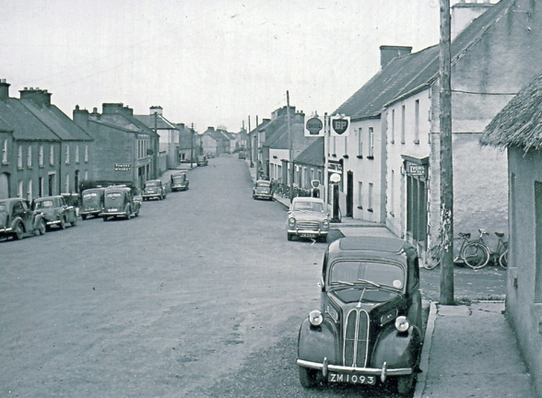

- There was ……………………………………………………..
- There were ……………………………………………………
- There wasn’t ………………………………………………..
- There weren’t ………………………………………………
Now

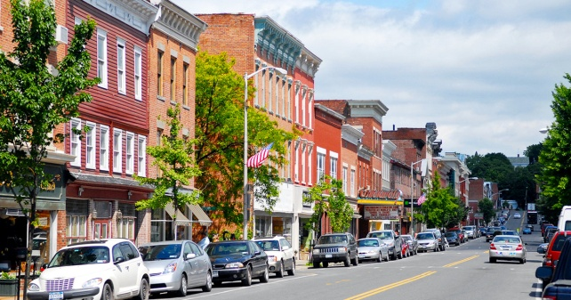

- There is ………………………………………………………….
- There are ……………………………………………………….
- There isn’t ……………………………………………………..
- There aren’t …………………………………………………..

Zadanie 3. Napisz krótki tekst o Twoim miasteczku. Użyj wcześniej poznanych przymiotników:

My town!

Hi, my name is ……………………. and I live in ………………………………………………………………………. …………………………………………………………………………………………………………………………………………………………………………………………………………………………………………………………………………………………………………………………
……………………………………………………………………………………………………………………………………………………………………………………………………………………………………………………………………………………………………………………………………………………………………………………………………………………………………………………………………………………………………………………………………………………………………………………………………………………………………………………………………………………………………………………………………………………………………………………………………………………………………………………………………………………………………………………………………………………………………………………………………………………………………………………………………………………………………………………………………………………………………………………………………………………………………………………………………………………………………………………………………………………………………………………………………………………………………………………………………………………………………………………………………………………………………………………………………………………………………

24.03.2020r. – wtorek

Zadanie 1. Zaznacz słowo, które nie pasuje do pozostałych:

- Bank – shop – clean – park
- Opposite – next to – police station – in front of
- Hospital – boring – restaurant – theatre
- Museum – hotel – between – film studio
- Stadium – small – modern – quiet
- Post office – supermarket – busy – swimming pool

Zadanie 2. Popatrz na zdjęcia I uzupełnij zdania:

- Let’s see a film in the ………………………….
- 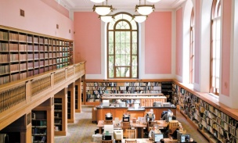 She often gets books from the …………………………………………
- The coffee at this ………………………. is very good.
- 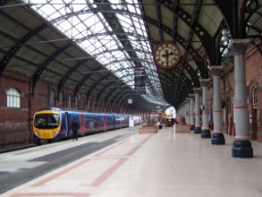 Dad always meets my grandparents at the …………………………………….

Zadanie 3. Uzupełnij pytania czasownikiem ‘to be’ w czasie przeszłym. Następnie dopasuj poprawne odpowiedzi:

- ………………….. Elena and Lucas at Amy’s house?
- ………………….. Tom in town last Saturday?
- ………………….. is school on Saturday?
- …………………... Elena at her grandparent’s house?
- …………………… Lucas and his family at a restaurant?
- Where ………………… the children last Saturday?

Odpowiedzi:
- No, she wasn’t.
- Yes, they were.
- Yes, he was.
- They were at the cinema.
- No, they weren’t.
- No, it wasn’t

Zadanie 4. Uzupełnij dialog słowami z ramki.

Straight looking me on turn for

Boy: Excuse ……….., I’m ………………….. for the ciemna. Is it ………………….?
Girl: No, it isn’t. Go ……………………….. on, past the bank. Then ………………….. right. The cinema in …………………….. the left, opposite the café.

Zadanie 5. Wskaż turyście drogę do włoskiej restauracji.
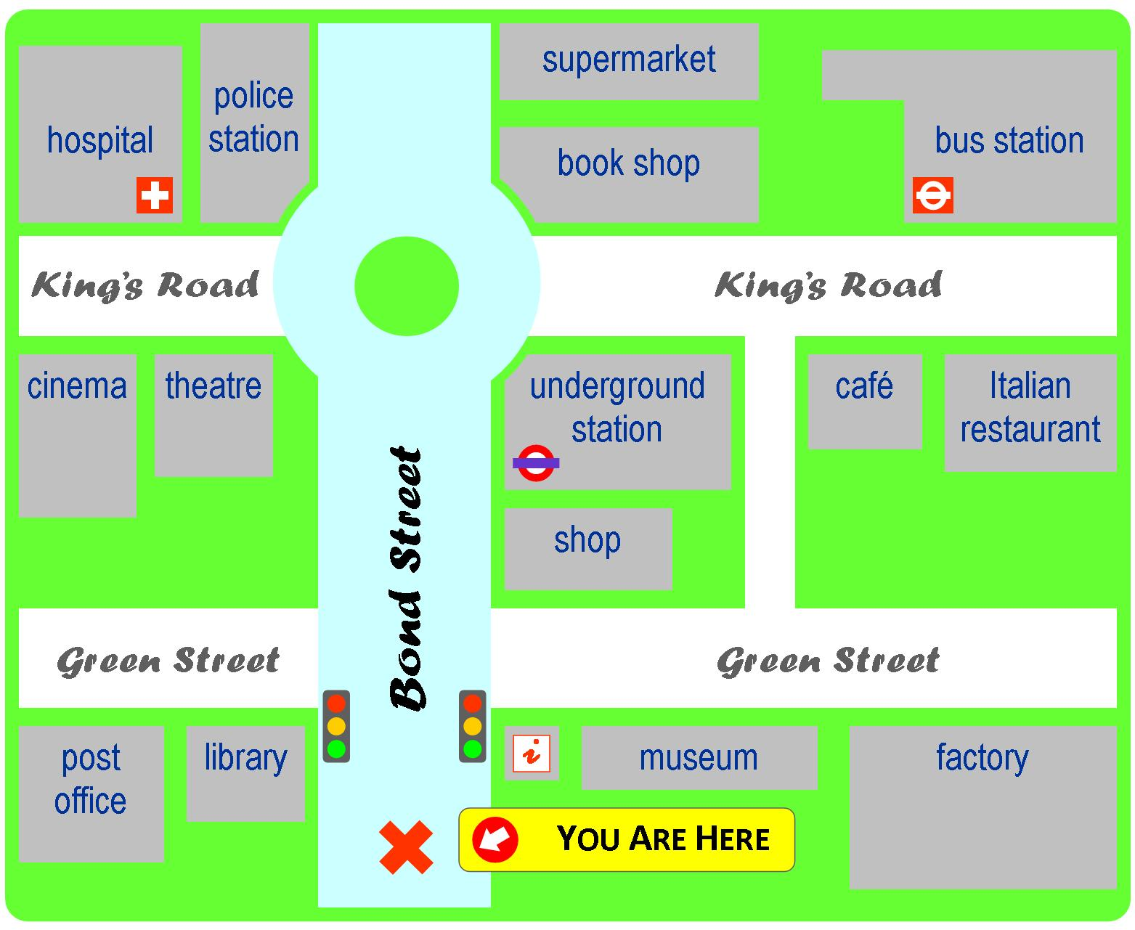
Słowniczek:
- a roundabout – rondo

………………………………………………………………………………………………………………………………………………………………………………………………………………………………………………………………………………………………………………
………………………………………………………………………………………………………………………………………………………………………………………………………………………………………………………………………………………………………………
………………………………………………………………………………………………………………………………………………………………………………………………………………………………………………………………………………………………………………
………………………………………………………………………………………………………………………………………………………………………………………………………………………………………………………………………………………………………………

